WEB PART 1

PROPOSAL

TERRI CIARa kleinbooi

2025

Contents

## Page 1…………………………………………………………… Business overview/ research

## Page 2…………………………………………………………… Business overview/ research

## Page 3…………………………………………………………… Business overview/ research

## Page 4…………………………………………………………… Business overview/ research

## Page 5…………………………………………………………… Sitemap

## Page 6…………………………………………………………… Contact Us Wireframe

## Page 7……………………………………………………………Enquiry Wireframe

## Page 8……………………………………………………………Product Wireframe

## Page 9…………………………………………………………… About Us Wireframe

## Page 10……………………………………………………………Index Wireframe

Website Project Proposal: Gemstone Haven

**1. Organisation Overview**

- Name: Gemstone Haven   
- Founded: 2025   
- Brief History:   
  Gemstone Haven was established in 2025 as a jewellery brand dedicated to celebrating women’s beauty through timeless, elegant, and comfortable designs. Unlike traditional jewellery brands that often prioritise luxury over comfort, Gemstone Haven focuses on creating pieces that combine elegance, softness, and wearability for modern women.   
   
- Mission Statement:   
  To provide elegant, high-quality jewellery that makes women feel as good as they look.   
   
- Vision Statement:   
  To become a trusted global destination for jewellery that embodies elegance, comfort, and individuality.   
   
- Target Audience:   
  Women at the appropriate age who value elegance, self-expression, and comfort in their fashion choices. This includes young professionals, brides-to-be, and gift shoppers seeking timeless gemstone jewellery.

**2. Website Goals and Objectives**

- Goals:   
  - Build brand awareness and showcase Gemstone Haven’s unique identity.   
  - Provide an elegant online platform that reflects the brand’s values of elegance, softness, and comfort.   
  - Enable product browsing and customer enquiries.   
  - Strengthen customer engagement through contact and enquiry forms.   
   
- Objectives / KPIs:   
  - Increase website traffic by 20% within the first six months.   
  - Achieve at least 100 customer enquiries within three months of launch.   
  - Maintain a 90% positive user satisfaction rate for navigation and design.   
  - Increase returning visitors by 15% within six months.

**3. Current Website Analysis**

No existing website — this is a new development project.

**4. Proposed Website Features and Functionality**

- Homepage:   
  - Serves as an overview/summary of the entire website.   
  - Includes a banner with a featured jewellery collection.   
  - Highlight of top products or collections with links to view more.   
  - Quick contact information and social media links.   
   
- About Us:   
  - Story of Gemstone Haven (founded 2025).   
  - Our values and the service we intend to provide.   
  - Commitment to elegance, softness, and comfort through our team.   
   
- Collections / Products Page:   
  - Categories of jewellery (rings, necklaces, earrings, bracelets).   
  - Each with high-quality images, descriptions, and price.   
  - Option to add to cart (not fully functional)   
   
- Enquiry Page:   
  - Dedicated form where customers can request details about products, pricing, or custom designs.   
  - Option for message or concerns.  
  - Links to contact details and social media (footer).   
   
- Contact Page:   
  - General contact form.   
  - Email, phone number, and physical address.    
 

**5. Design and User Experience**

- Overall Aesthetic: Elegant, soft, luxurious yet approachable.   
- Colour Palette: #daab00, #fff3e3, #ecc386.   
- Typography:   
  - Headings: Javanese Text font for elegance.   
  - Body: Cinzel, for readability and comfort.   
- Layout & Design: Minimalist, clean design with strong emphasis on product imagery.   
- UX Considerations:   
  - Clear navigation menu with logical hierarchy.   
  - Mobile responsiveness for accessibility on all devices.   
  - Alt text for all images for accessibility.   
  - Readable font sizes for ease of browsing.   
- Wireframes: To be developed for homepage, about page, enquiry page, contact page, product page

**6. Technical Requirements**

- Domain: [www.gemstonehaven.com](http://www.gemstonehaven.com/) (proposed).   
- Technologies: HTML5, CSS3, JavaScript for initial development. 

**7. Timeline and Milestones**

- Week 1–2: Research and planning (sitemap, content sourcing).   
- Week 3: Wireframe creation.   
- Week 4–5: Website design (UI/UX).   
- Week 6: Development (HTML, CSS, JavaScript).   
- Week 7: Testing, bug fixing, and revisions.   
- Week 8: Final deployment and presentation.

**8. Budget (Estimated)**

- Domain: [www.gemstonehaven.com](http://www.gemstonehaven.com/)

-R300 since the site is low and has minimal maintenance.

- Website development: R2000   
- Maintenance: R800/month

-Content Writing: Included in website development

Images and media: Included in website development  
- Marketing (optional): R1500/month for social media campaigns

**9. References**

- Colour palette and typography references from canva.   
- Market research on jewellery e-commerce trends and websites such as lovisa.

**Sitemap**

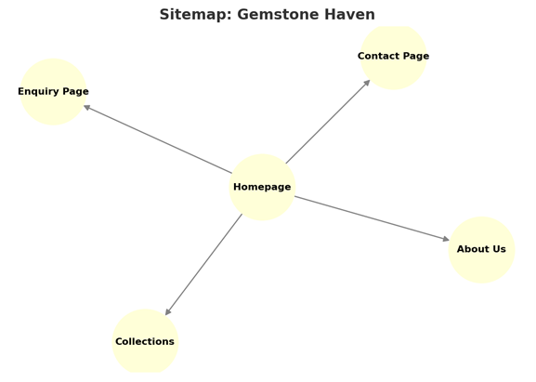

NAV

LOGO

FOOTER

BUTTON

TEXTBOX

TEXTBOX

TEXTBOX

TEXTBOX

CONTENT/INTRO

NAV

LOGO

FOOTER

CONTENT

NAV

LOGO

FOOTER

CONTENT

CONTENT

CONTENT

CONTENT

CONTENT

CONTENT

NAV

LOGO

CONTENT

IMAGE

IMAGE

IMAGE

CONTENT

IMAGE

IMAGE

IMAGE

IMAGE

FOOTER

CONTENT

FOOTER

IMAGE

IMAGE

IMAGE

IMAGE

IMAGE

IMAGE

IMAGE

IMAGE

IMAGE

CONTENT

VIDEO

BANENR

NAV

LOGO